**Marketing Research Project**

**Client: Yahoo**

Yahoo!, Inc.

Project: Streaming Service

Research Objective: Yahoo is considering offering streaming service. **We would like to explore the viability of offering a streaming entertainment service.**

**Part 1**

1. **Who are the main competitors in the streaming services?**

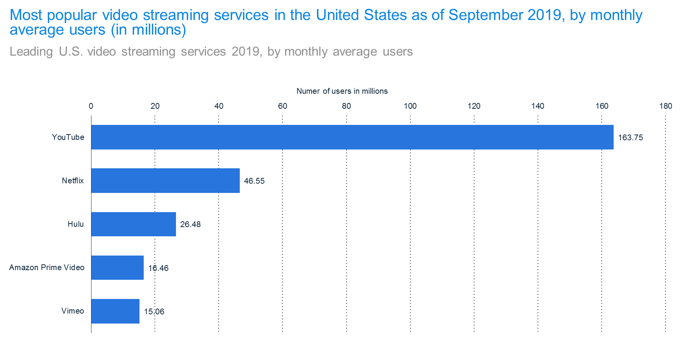Streaming services provide online entertainment in the form of movies, television shows, music, videos, and other original content. Within each entertainment category, there are a number of prominent providers that dominate the market share for the streaming services. In terms of video streaming services in the US, YouTube is by far the leading provider in terms of the average number of users per month (163.75 million users). The second and third largest providers are Netflix and Hulu, with 46.55 and 26.48 million monthly average users, respectively. This information was gathered from Statista.

In terms of video subscription services (i.e. paid access to streaming service content), Netflix owns the largest market share, with 60.2 million subscribers. Hulu and Amazon each have approximately 26 million subscribers, while all other video subscription services accounted for ≤5 million subscribers. Please see below for the graph provided from Statista.

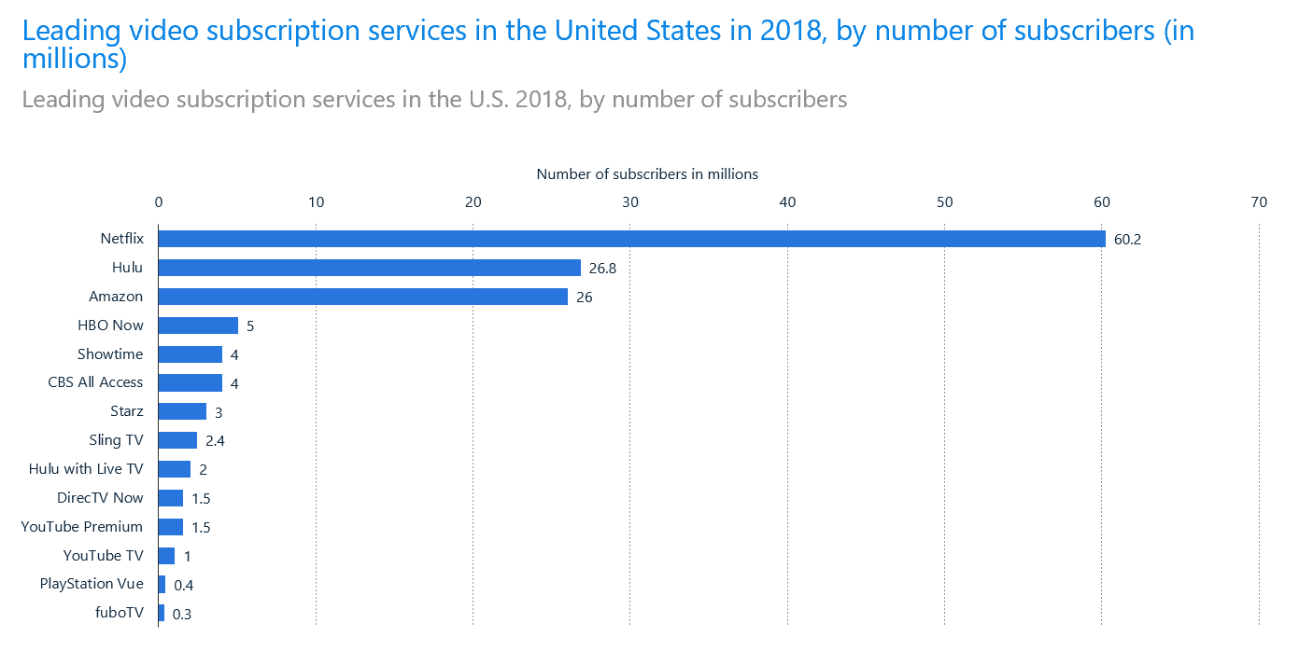

Music is another major category of streaming services entertainment. While Apple and Spotify lead the way, accounting for 24% each of mobile reach, the distribution among the major competitors is much less skewed than described above for video streaming and video subscription services, as evidenced in the graph below. Again, this information was derived from Statista.

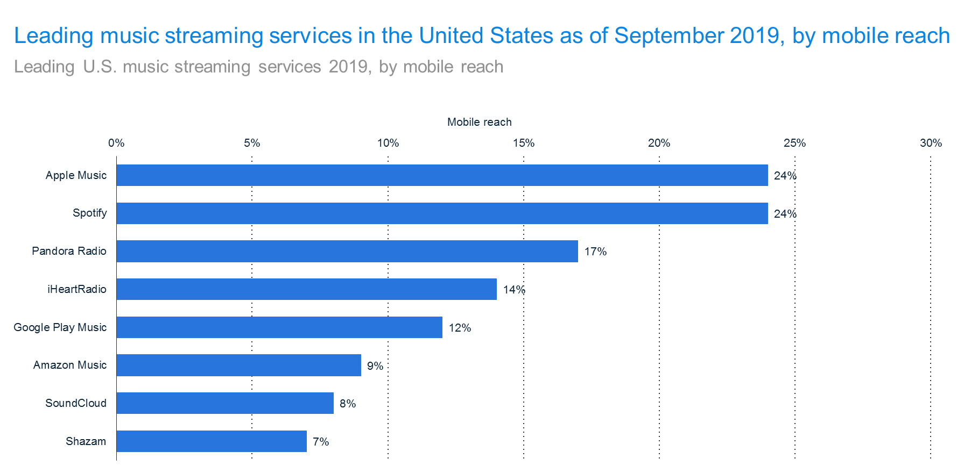

1. **Which segment(s) of our customers would be interested in this service?**

In order to identify a potential target market for a Yahoo Streaming Service, a Simmons crosstab was run. Various age cohorts were compared to streaming service usage/habits. Clear trends in the use of video streaming services emerge when assessing usage by age group. When evaluating usage of Netflix (including Netflix services requiring a monthly fee for access), Amazon Prime Instant Video, YouTube, and Hulu, survey respondents 18-24, 25-34, and 35-44 years of age were much more likely than the general US population to report using these services within the past 30 days. The ranges were 21%-72% more likely for Netflix (with 31%-57% for fee-based services), 38%-56% more likely for Amazon Prime Instant Video, 25%-39% more likely for YouTube, and 26%-89% more likely for Hulu. The one exception to this trend was the 18-24 year old cohort who were 19% less likely than the general US population to use the paid Amazon Prime Instant Video service. The 45-54 year old cohort had generally consistent usage rates as the overall US population, though some noticeable differences are evident in Netflix and Hulu (≈11% and 21% less likely to use these services). The older age groups (55-64, and 65+ years of age) were substantially less likely to use video streaming services relative to the general population. The most extreme percentages were seen for respondents 65+ years of age, who were 60%, 49%, 55%, and 67% less likely to use Netflix, Amazon Prime Instant Video, YouTube, and Hulu in the past 30 days. Furthermore, among users of Netflix, YouTube, and Hulu, it is clear that the younger age groups are overwhelmingly more likely than the overall population to use these video services at a high frequency within a 30 day interval (i.e. 6 to 16 times per month); the older age cohorts were far less likely to use these services on a consistent basis (0 to ≤5 times per month). MRI was used to highlight insights specific to movie streaming services. According to the database, 28% and 22% of movie streamers were ages 25-34 and 35-44 respectively. These were the highest reported percentages among all age cohorts. Older age groups were significantly less likely to stream movies. Just 8.92% and 6.47% of movie streamers are members of the age groups 55-64 and 65+ respectively in the continental US.

When evaluating trends in streaming music services by age group, it is clear that younger age groups are more likely to subscribe to such services. Survey respondents 18-24, 25-34, and 35-44 years of age were far more likely than the general US population to subscribe to Spotify, Pandora, iHeartRadio, or Apple Music. The highest numbers are among 18-24 year old respondents, who were 155%, 56%, and 124% more likely to use Spotify, Pandora, and Apple Music than the general population. iHeartRadio was more popular among 25-34 and 35-44 year olds, with such users being 22% and 51%, respectively, more likely to use these services. When specifically assessing paid subscriptions to Spotify and Pandora, the youngest users (18-24 years of age) were 211% more likely than the general population to use Spotify but were 22% less likely to use Pandora. On the contrary, respondents 25-44 years of age were as or more likely to use these paid services. All Simmons crosstabs are included at the end of this paper.

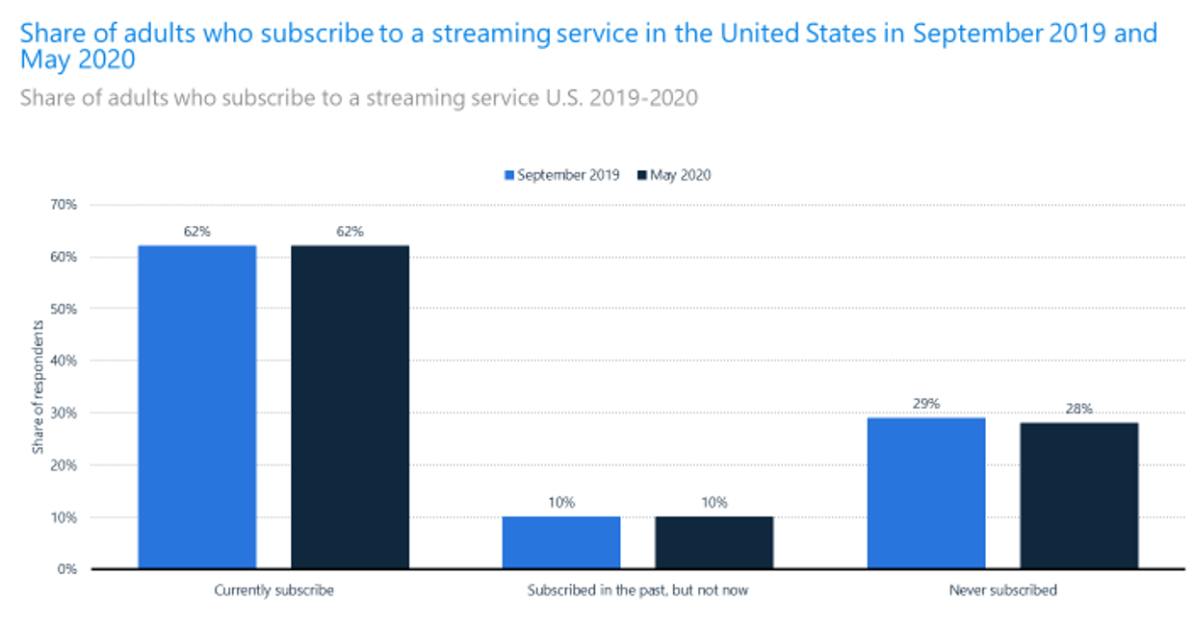Based on the data presented above, it is clear that streaming services are very popular among the US population. According to Statista, as of May 2020, an estimated 62% of adults were reported to be a current subscriber to one or more streaming services and an additional 10% indicated that, while not a current subscriber, had been a subscriber in the past. The probability of subscribing to one or more streaming services is highly correlated with age.

In particular, the probability of subscribing to one or more services declines significantly as age increased. Statista data suggests that as of 2017, approximately 23% of survey respondents 18-29 years of age indicated that they were not currently subscribed to a streaming service, while this figure more than doubles to 55% and 68% for respondents 55-64 and 65+ years of age, respectively. Older survey respondents were also less likely to subscribe to multiple services.

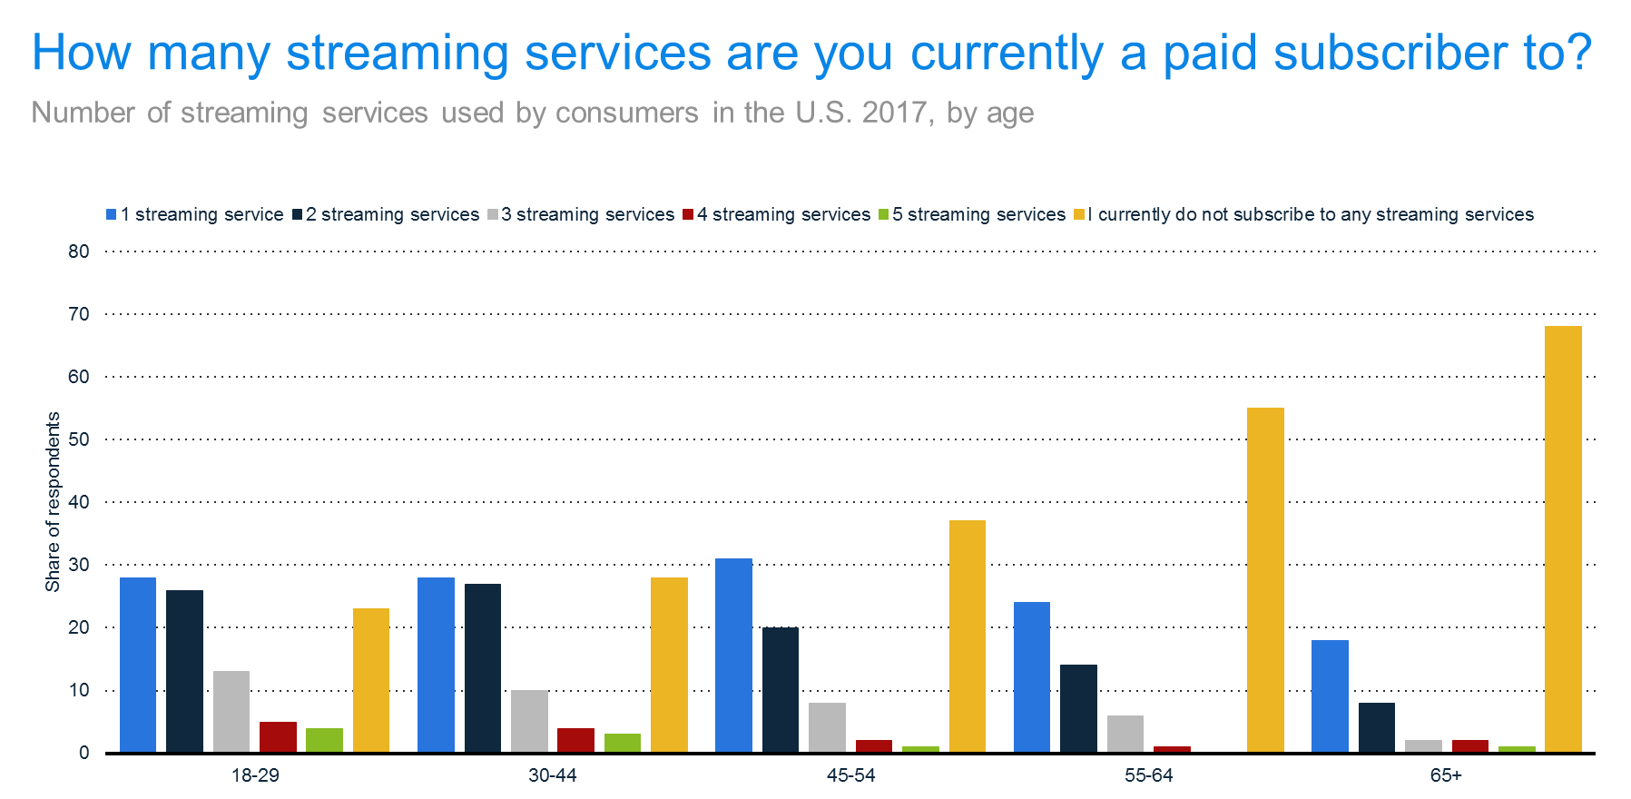

1. **What content is most desirable for our audience (e.g. original content, movies, TV shows, etc.)**

In evaluating whether Yahoo should invest in developing streaming services, it is important to understand the current typical Yahoo user. According to Simmons data, among those who indicated that Yahoo was their primary search engine, the majority of respondents were ≥45 years of age (18.9% 45-54 years of age, 21.4% 55-64 years of age, and 19.7% 65+ years of age). In particular, the 45-54 and 55-64 year old age cohorts were 9% and 26%, respectively, more likely to Yahoo as their primary search engine relative to the general US population, while respondents 18-24 years of age were 34% less likely to use Yahoo as their primary engine. Of note, 35-44 and 45-54 year olds were roughly 25% more likely to use Yahoo as a secondary search engine than the general US population. Data from SRDS, which pools data from ComScore, supports these findings as it found older age demographics not only to have higher internet usage rates but to also use Yahoo services more often in comparison to younger age cohorts.

Ultimately, the older age demographic that Yahoo search engine appeals to are not a significant users of streaming services. According to a telephone survey conducted among senior citizen by the Communications Law and Policy Institute at New York Law School and Older Americans Technology Services, 75% of respondents indicated they were motivated to use the internet to communicate with family and friends, 58% were motivated by shopping online for products/services, and 53% were motivated by access to health care and medical information. Only 17% of respondents indicated that the ability to watch television shows, movies, and other videos was a motivating factor in internet usage.

Similar conclusions are obtained via Simmons data when considering the attitudes and beliefs about the internet and entertainment sources among older age demographics. Specifically, older age groups indicated that the internet was a primary source of entertainment at much lower rates than the general US population and, in accordance, CDs and DVDs remain as more viable options for the mode of entertainment consumption for older age groups relative to the overall population. Television remains a primary source of entertainment for older age groups; for example, respondents 55-64 years of age are 29% more likely than the US population to cite television as the primary source of media entertainment. Older respondents were also much more likely than younger age groups to report that their internet activity was below or far below average. Please see the Simmons crosstab provided at the end of this paper.

Based on the research findings, Yahoo faces several challenges in establishing itself as a source of media entertainment. Firstly, the primary users of Yahoo are older (45+ years of age) and primarily use the internet for communication and information purposes rather than for entertainment. Secondly, there are significant barriers to entry as there are many video and music services already available on the market. Particularly in the case of video services, there are a few suppliers who dominate the market, making it difficult for a new company to attract customers and gain market share. Yahoo will likely need a very targeted approach to reach its key demographic or will need to focus on attracting younger users who are more inclined to use streaming services to its platform.

**References**

Verto Analytics. "Most popular video streaming services in the United States as of September 2019, by monthly average users (in millions)." Chart. November 13, 2019. Statista. Accessed October 09, 2020. <https://www-statista-com.rlib.pace.edu/statistics/910875/us-most-popular-video-streaming-services-by-monthly-average-users/>

eMarketer. "Leading video subscription services in the United States in 2018, by number of subscribers (in millions)." Chart. May 8, 2019. Statista. Accessed October 09, 2020. <https://www-statista-com.rlib.pace.edu/statistics/185390/leading-cable-programming-networks-in-the-us-by-number-of-subscribers/>

Verto Analytics. "Leading music streaming services in the United States as of September 2019, by mobile reach." Chart. November 13, 2019. Statista. Accessed October 09, 2020. <https://www-statista-com.rlib.pace.edu/statistics/798758/music-streaming-service-mobile-only-user/>

Statista, 2019

Simmons, 2017

“2019 Spring GfK Reporter MRI.” New York, 2019.

Morning Consult. "Share of adults who subscribe to a streaming service in the United States in September 2019 and May 2020." Chart. May 21, 2020. Statista. Accessed October 09, 2020. <https://www-statista-com.rlib.pace.edu/statistics/325162/svod-penetration-rate/>

Morning Consult. "How many streaming services are you currently a paid subscriber to?." Chart. August 21, 2017. Statista. Accessed October 09, 2020. <https://www-statista-com.rlib.pace.edu/statistics/742510/number-streaming-services-used-by-age/>

Simmons, 2017

“Yahoo!” Standard Rate and Data Service. New York, August 2020. https://next-srds-com.rlib.pace.edu/datacard/show/539029.

Schaub, Hillary. “Why Senior Citizens Use the Internet.” Brookings. Brookings, July 29, 2016. <https://www.brookings.edu/blog/techtank/2014/04/11/why-senior-citizens-use-the-internet/>.

Simmons, 2017

**Statista Graphs**

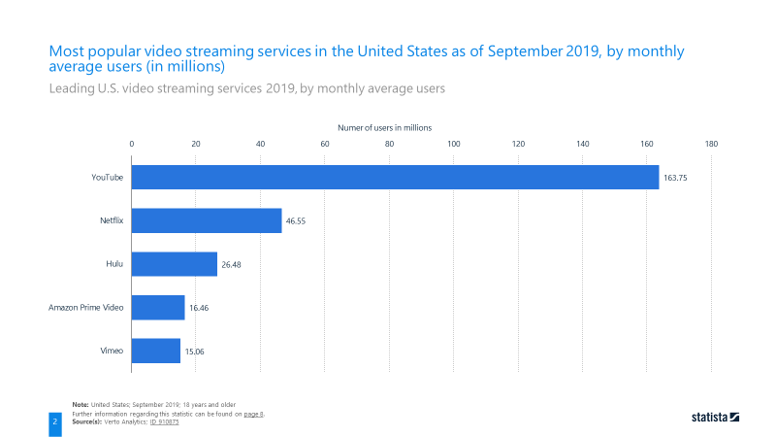

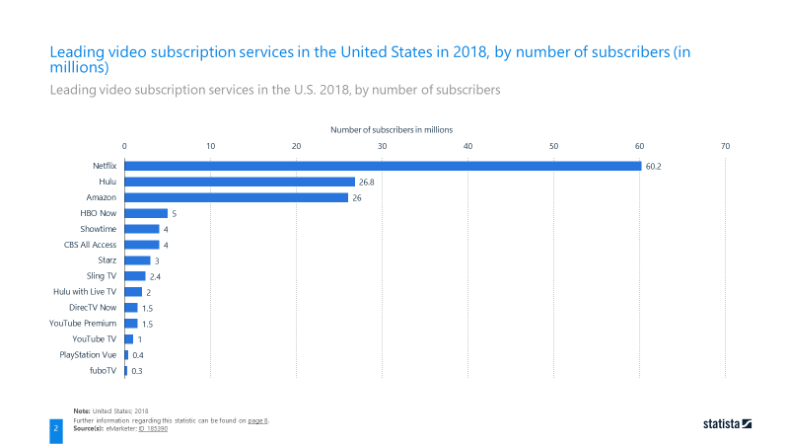

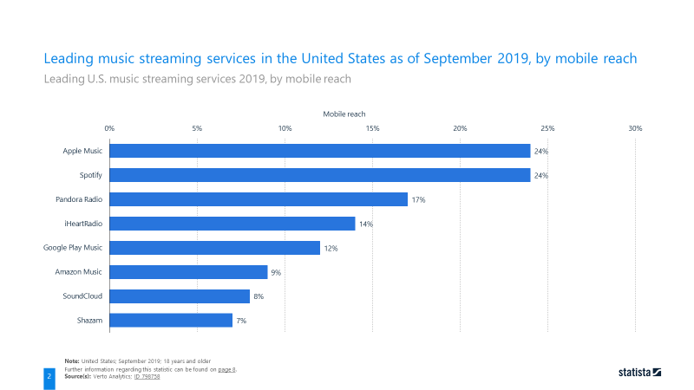

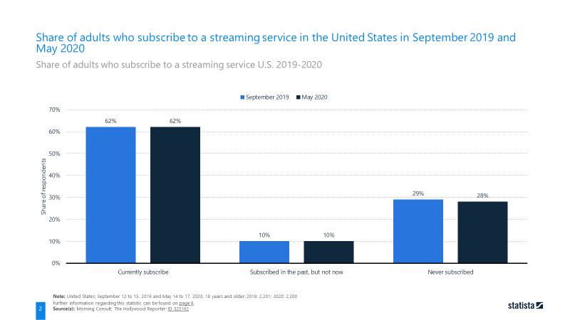

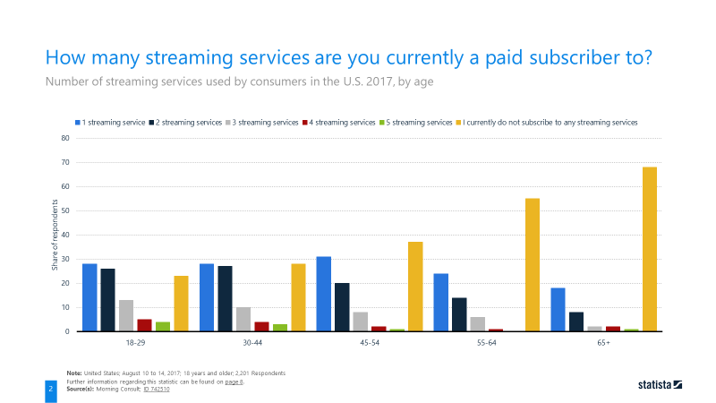

**Simmons Crosstabs**









**MRI**



**SRDS**

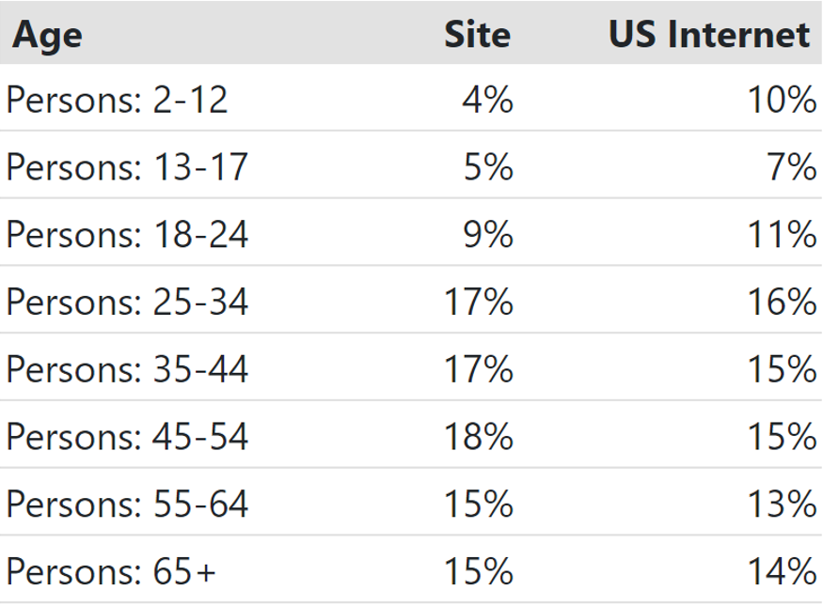

**Part 2:**

I. Survey Questions (Sample Size: 32)

|  |  |
| --- | --- |
| **Question Number** | **Question** |
| 1 | Do you use online streaming services? |
| 2 | How many times per month do you use streaming services? |
| 3 | Which of these video streaming services do you use? Check all that apply. |
| 4 | Which video streaming service do you use the most (select one)? |
| 5 | Which of these music streaming services do you use? Check all that apply. |
| 6 | Which music streaming service do you use the most (select one)? |
| 7 | What type of content do you stream most often? |
| 8 | Do you pay for a subscription to any streaming service? |
| 9 | What are you willing to pay monthly for access to a streaming service? |
| 10 | Select all streaming services you subscribe to. Check all that apply: |
| 11 | How often do you use Yahoo? |
| 12 | Would you subscribe to a Yahoo streaming service? |
| 13 | Choose the gender with which you identify. |
| 14 | What is your age? |

II. Survey Results

1) Who are the main competitors in the streaming service?

From this questions I also intend to gain insight on the following:

* How much market share does each competitor have?
* How many people are using these services and what demographic are they a part of?
* Is there a high demand for streaming services?

Questions 3, 4, 5 and 6 from my Qualtrics survey address the research question of who are the main competitors in the streaming service and how much market share each competitor has. Of the 28 survey respondents who indicated that they use online streaming services (ie, responded “Yes” to Question 1), approximately 86% reported using YouTube, 54% reported using Netflix, 32% reported using Amazon Prime, and 21% reported using Hulu for video streaming services. Less than 10% of such respondents indicated using Vimeo or another video streaming service (see Figure 1). When asked to identify the single most frequently used video service, a similar trend was seen, with roughly 50%, 36%, and 14% of online streaming service users selecting YouTube, Netflix and Amazon Prime video services, respectively; no other video streaming service providers were indicated as being the most frequently used provider.

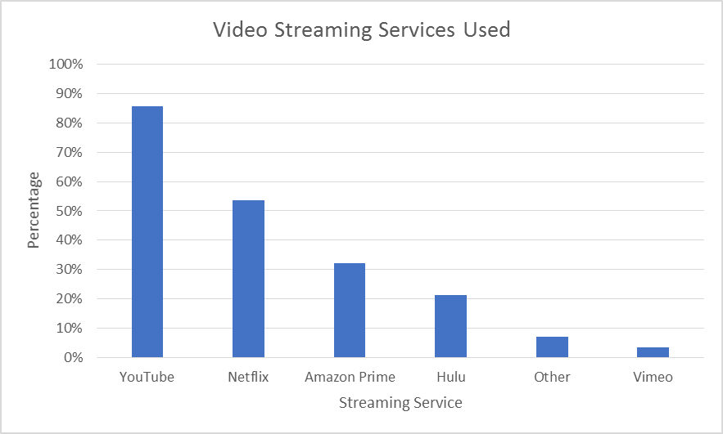

**Figure 1** Video Streaming Services Used (Among Participants Who Use Streaming Services; N = 28)

While the data above make it clear that in terms of video streaming services, a few key providers dominate the market, the music streaming industry is more competitive. Among the 28 online streaming service users surveyed, approximately 29% indicated using Apple Music and Spotify, while Pandora Radio, iHeartRadio, and Google Play Music were identified by 14% to 18% of the respondents (see Figure 2). Similarly, the distribution of the most frequently used music streaming service was relatively uniformly distributed across music streaming service providers. While Spotify was identified as the most frequently used music streaming service (25% of respondents), Apple Music and Pandora Radio were each selected by nearly 18% of respondents, followed by iHeartRadio (≈11%).

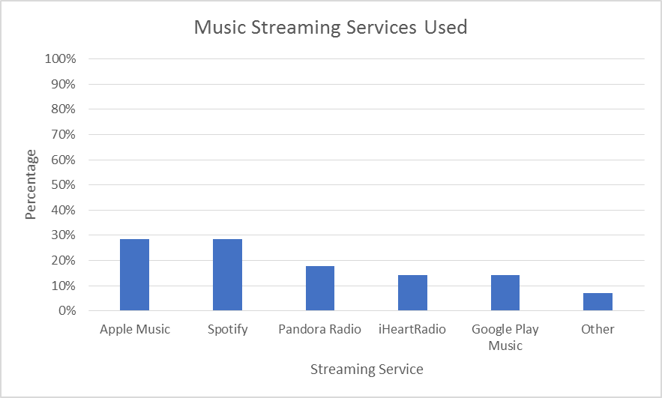

**Figure 2** Music Streaming Services Used (Among Participants Who Use Streaming Services; N = 28)

Question 1 addresses the research question of how many people are using online streaming services. Of the 32 survey respondents, 28 (87.5%; 95% confidence interval: 71.0% to 96.5%) use online streaming services. Cross tabulations of Questions 13 and 14 versus Question 1 (Table 1 and Table 2, respectively) provide insight into what demographics utilize online streaming services. Of the 21 female respondents, 17 (≈81%) reported using online streaming services; all male participants surveyed (n = 11) reported using online streaming services. In terms of the distribution of responses by age group, 14/17 = 82.4% of participants ≤34 years of age, 13/13 = 100% of participants 35 to 64 years of age, and 1/2 = 50% of participants ≥65 years of age indicated using streaming services. While the small sample size for participants ≥65 years of age precludes meaningful interpretation within this subgroup, it is clear that the majority of middle-aged and younger age groups use online streaming services.

|  |  |  |  |
| --- | --- | --- | --- |
| **Table 1** Online Streaming Service Use by Gender | | | |
| **Gender** | **Do you use online streaming services?** | | **Grand Total** |
| **Yes** | **No** |
| Female | 17 (53.1%) | 4 (12.5%) | 21 (65.6%) |
| Male | 11 (34.4%) | 0 (0.0%) | 11 (34.4%) |
| **Grand Total** | **28 (87.5%)** | **4 (12.5%)** | **32 (100.0%)** |
| Note: All percentages are calculated out of the total number of survey respondents (32). | | | |

|  |  |  |  |
| --- | --- | --- | --- |
| **Table 2** Online Streaming Service Use by Age Category | | | |
| **Age Category (Years)** | **Do you use online streaming services?** | | **Grand Total** |
| **Yes** | **No** |
| Less than 18 | 2 | 0 | 2 |
| 18-24 | 6 | 2 | 8 |
| 25-34 | 6 | 1 | 7 |
| 35-44 | 2 | 0 | 2 |
| 45-54 | 3 | 0 | 3 |
| 55-64 | 8 | 0 | 8 |
| 65 or older | 1 | 1 | 2 |
| **Grand Total** | **28** | **4** | **32** |

The findings from Q1 make it clear that there is a high demand for online streaming services. Question 2 helps to quantify this demand by estimating how frequently the services are used on a monthly basis. Of the 28 online streaming services users, 13 (46.4%) reported using these services 10 or fewer times per month, and 6 (21.4%) can be considered “high frequency users” who use streaming services more than 20 times per month. Cross tabulations of Question 2 versus Questions 13 and 14 (Table 3 and Table 4, respectively) reveal trends in the frequency of streaming usage by gender and age group. The proportions of male and female participants in each of the streaming service frequency categories was similar, with the exception of the “More than 20” times per month category for which only 9.5% of female respondents selected versus 36.4% of male respondents. In terms of the frequency of use by age category, a clear difference between younger versus older respondents can be seen. Specifically, among the 17 respondents ≤34 years of age, 11 reported (64.7%) using streaming services at least 11 times per month, while among the 15 respondents >34 years of age, only 4 (26.7%) use these services 11 times or more per month.

|  |  |  |  |  |  |  |
| --- | --- | --- | --- | --- | --- | --- |
| **Table 3** Frequency of Streaming Service Use by Gender | | | | | | |
| **Gender** | **How many times per month do you use streaming services?** | | | | | **Grand Total** |
| **0** | **1-5** | **6-10** | **11-20** | **More than 20** |
| Female | 4 | 6 | 3 | 6 | 2 | 21 |
| Male | 0 | 3 | 1 | 3 | 4 | 11 |
| **Grand Total** | **4** | **9** | **4** | **9** | **6** | **32** |

|  |  |  |  |  |  |  |
| --- | --- | --- | --- | --- | --- | --- |
| **Table 4** Frequency of Streaming Service Use by Age Category | | | | | | |
| **Age Category (Years)** | **How many times per month do you use streaming services?** | | | | | **Grand Total** |
| **0** | **1-5** | **6-10** | **11-20** | **More than 20** |
| Less than 18 | 0 | 0 | 0 | 1 | 1 | 2 |
| 18-24 | 2 | 2 | 0 | 3 | 1 | 8 |
| 25-34 | 1 | 1 | 0 | 2 | 3 | 7 |
| 35-44 | 0 | 1 | 1 | 0 | 0 | 2 |
| 45-54 | 0 | 2 | 1 | 0 | 0 | 3 |
| 55-64 | 0 | 3 | 2 | 2 | 1 | 8 |
| 65 or older | 1 | 0 | 0 | 1 | 0 | 2 |
| **Grand Total** | **4** | **9** | **4** | **9** | **6** | **32** |

In terms of paid subscription services, there are many established competitors in the marketplace. In Question 10, survey respondents selected all online streaming providers to whom they subscribe to. Among the 19 people who indicated that they pay for streaming services (Question 8), nearly 90% reported subscribing to Netflix. Approximately 58% subscribe to YouTube and 37% to Amazon Prime, Apple Music, and Pandora Radio; nearly one third of respondents who pay for streaming services subscribe to Hulu. These percentages also reveal that people who pay for streaming services are often subscribers to multiple platforms (see Figure 3).

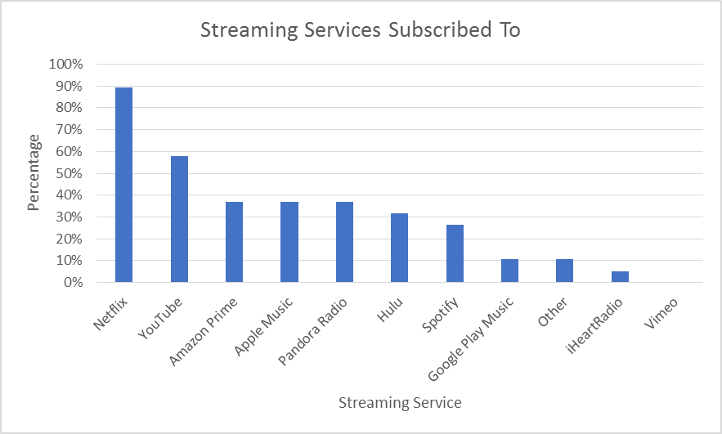

**Figure 3** Streaming Services Subscribed To (Among Participants Who Pay for Streaming Services; N = 19)

2) Which segment(s) of our customers would be interested in this service?

In order to understand what segment of the Yahoo customer base would be interested in a Yahoo online streaming service, it is necessary to understand the demographics of Yahoo’s current customers. This information can be found in Question 11 and cross tabulations of Question 11 with Questions 12, 13, and 14. Overall, only 10 (31.3%) of the 32 people surveyed reported using Yahoo on a consistent basis (either monthly, weekly, or daily). The 10 users were evenly split by gender (Table 5). There is some evidence that female users are more likely to be high-volume users of Yahoo (4 of the 5 female Yahoo users identified as being a daily user, while only 1 of the 5 male users responded as such). When looking at the distribution of Yahoo users by age group, it is clear that older people tend to use Yahoo more than younger people; of the 10 Yahoo users, 7 were ≥45 years of age or older while the remaining 3 were between 18 to 34 years of age (Table 6).

|  |  |  |  |
| --- | --- | --- | --- |
| **Table 5** Yahoo Use by Gender | | | |
| **How often do you use Yahoo?** | **Gender** | | **Grand Total** |
| **Female** | **Male** |
| **Never** | **16** | **6** | **22** |
| **Monthly** | **0** | **2** | **2** |
| **Weekly** | **1** | **2** | **3** |
| **Daily** | **4** | **1** | **5** |
| **Grand Total** | **21** | **11** | **32** |

|  |  |  |  |  |  |  |  |  |
| --- | --- | --- | --- | --- | --- | --- | --- | --- |
| **Table 6** Yahoo Use by Age Category | | | | | | | | |
| **How often do you use Yahoo?** | **Age Category (Years)** | | | | | | | **Grand Total** |
| **Less than 18** | **18-24** | **25-34** | **35-44** | **45-54** | **55-64** | **65 or older** |
| **Never** | **2** | **7** | **5** | **2** | **2** | **3** | **1** | **22** |
| **Monthly** | **0** | **0** | **0** | **0** | **0** | **2** | **0** | **2** |
| **Weekly** | **0** | **0** | **0** | **0** | **1** | **1** | **1** | **3** |
| **Daily** | **0** | **1** | **2** | **0** | **0** | **2** | **0** | **5** |
| **Grand Total** | **2** | **8** | **7** | **2** | **3** | **8** | **2** | **32** |

It is also important to estimate the number of potential customers for a Yahoo streaming service, that is, the number of participants who would likely use such a service if it were available. Question 12 reveals that only 5 (15.6%) of the 32 survey respondents indicated that they would use a Yahoo streaming service if it were available. When looking at a cross tabulation of Questions 11 and 12 (Table 7), one participant who reported never using Yahoo indicated that they would use a Yahoo streaming service (this person also reported using YouTube, Netflix, and Other video services and Pandora Radio and Google Play Music services, is a subscriber to at least one paid streaming service, and uses streaming services 6 to 10 times per month); the remaining 4 respondents who indicated they would use a Yahoo streaming service were all current daily users of Yahoo.

|  |  |  |  |
| --- | --- | --- | --- |
| **Table 7** Willingness to Subscribe to a Yahoo Streaming Service by Current Yahoo Usage | | | |
| **How often do you use Yahoo?** | **Would you subscribe to a Yahoo streaming service?** | | **Grand Total** |
| **No** | **Yes** |
| **Never** | **21** | **1** | **22** |
| **Monthly** | **2** | **0** | **2** |
| **Weekly** | **3** | **0** | **3** |
| **Daily** | **1** | **4** | **5** |
| **Grand Total** | **27** | **5** | **32** |

These findings suggest that only very high current users of Yahoo (which may have a large older female constitution) would likely be interested in a Yahoo streaming service, while casual users may not have much interest.

3) What content is most desirable for our audience (e.g. original content, movies, TV shows, etc.)?

Question 7 and 9 (in conjunction with Questions 13 and 14) address the type of content that is most desirable for the current Yahoo customer base. The current female Yahoo users indicated that Movies and Music were the type of content they most commonly streamed, while original content was the type of content most frequently streamed by the male Yahoo users (Table 8). Trends in the type of content preferred are also seen by age group (Table 9). Younger age groups (respondents <45 years of age) cited movies and TV shows as their most frequent types of content streamed, while older respondents (≥45 years of age) were more inclined to select music and original content.

|  |  |  |  |
| --- | --- | --- | --- |
| **Table 8** Type of Content Streamed by Gender (Among Yahoo Users; N = 10) | | | |
| **Survey Respondents Who Use Yahoo** | | | |
| **What type of content do you stream most often?** | **Choose the gender with which you identify.** | |  |
| **Female** | **Male** | **Grand Total** |
| Movies | 2 | 0 | 2 |
| Music | 2 | 1 | 3 |
| None | 0 | 1 | 1 |
| Original content | 0 | 3 | 3 |
| TV shows | 1 | 0 | 1 |
| **Grand Total** | **5** | **5** | **10** |

|  |  |  |  |  |  |  |
| --- | --- | --- | --- | --- | --- | --- |
| **Table 10** Type of Content Streamed by Age Category (Among Yahoo Users; N = 10) | | | | | | |
| **Survey Respondents Who Use Yahoo** | | | | | | |
| **Age Category (Years)** | **What type of content do you stream most often?** | | | | | **Grand Total** |
| **Movies** | **TV shows** | **Music** | **Original content** | **None** |
| 18-24 | 1 | 0 | 0 | 0 | 0 | 1 |
| 25-34 | 1 | 1 | 0 | 0 | 0 | 2 |
| 45-54 | 0 | 0 | 1 | 0 | 0 | 1 |
| 55-64 | 0 | 0 | 2 | 3 | 0 | 5 |
| 65 or older | 0 | 0 | 0 | 0 | 1 | 1 |
| **Grand Total** | **2** | **1** | **3** | **3** | **1** | **10** |

III. Conclusions

Among the 28 respondents who use streaming services, 19 (67.9%) indicated that they currently pay for subscription services (per Question 8). While this shows that there is a high percentage of participants who are willing to pay for streaming services, this may not hold for the current Yahoo customer base, for which only 4 out of 10 indicated they would subscribe to a Yahoo streaming service if it were available (Table 11).

|  |  |  |  |
| --- | --- | --- | --- |
| **Table 11** Willingness to Subscribe to a Yahoo Streaming Service by Current Yahoo Usage Frequency (Among Yahoo Users; N = 10) | | | |
| **Survey Respondents Who Use Yahoo** | | | |
| **How often do you use Yahoo?** | **Would you subscribe to a Yahoo streaming service?** | | **Grand Total** |
| **No** | **Yes** |
| Daily | 1 | 4 | 5 |
| Monthly | 2 | 0 | 2 |
| Weekly | 3 | 0 | 3 |
| **Grand Total** | **6** | **4** | **10** |

Interestingly, of these 10 participants, 6 indicated that they are subscribers to one or more streaming services (4 of which subscribe to 3 or more services according to Question 10), which implies that while 60% of users are current streaming service subscribers, a much lower percentage of 40% are open to a Yahoo-provided service.

If Yahoo were to provide a service, the previous findings suggest that this service would be most appealing to current high-volume users of Yahoo (ie, daily users), which primarily consists of older and female demographics. Another important aspect of the service that would need to be determined would be the appropriate price point for the streaming service. Among current Yahoo users, younger age groups are more willing to spend higher amounts than older age groups; no one above the age of 34 was willing to spend more than $20 on a monthly streaming service subscription, and 4 of the 6 respondents ≥45 years of age were only willing to spend less than $10 on such services (Table 12). There is some evidence however that female users are more likely to spend more money on subscription services than male users (all female users were willing to spend at least $10 while only one male user responded similarly) (Table 13).

|  |  |  |  |  |
| --- | --- | --- | --- | --- |
| **Table 12** Willingness to Pay for Streaming Services by Age Category (Among Yahoo Users; N = 10) | | | | |
| **Survey Respondents Who Use Yahoo** | | | | |
| **Age Category (Years)** | **What are you willing to pay monthly for access to a streaming service?** | | | **Grand Total** |
| **Less than $10** | **$10-20** | **More than $20** |
| 18-24 | 0 | 0 | 1 | 1 |
| 25-34 | 0 | 1 | 1 | 2 |
| 45-54 | 0 | 1 | 0 | 1 |
| 55-64 | 4 | 1 | 0 | 5 |
| 65 or older | 0 | 1 | 0 | 1 |
| **Grand Total** | **4** | **4** | **2** | **10** |

|  |  |  |  |
| --- | --- | --- | --- |
| **Table 13** Willingness to Pay for Streaming Services by Gender (Among Yahoo Users; N = 10) | | | |
| **Survey Respondents Who Use Yahoo** | | | |
| **What are you willing to pay monthly for access to a streaming service?** | **Choose the gender with which you identify.** | | **Grand Total** |
| **Female** | **Male** |
| Less than $10 | 0 | 4 | 4 |
| $10-20 | 3 | 1 | 4 |
| More than $20 | 2 | 0 | 2 |
| **Grand Total** | **5** | **5** | **10** |